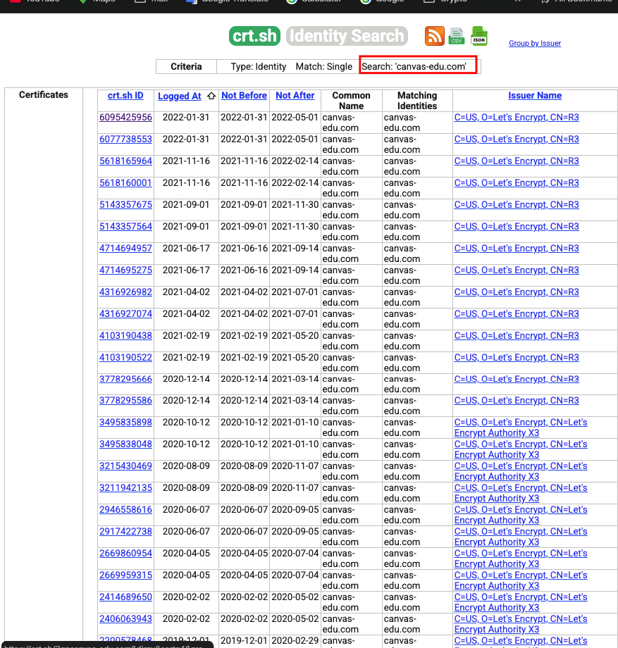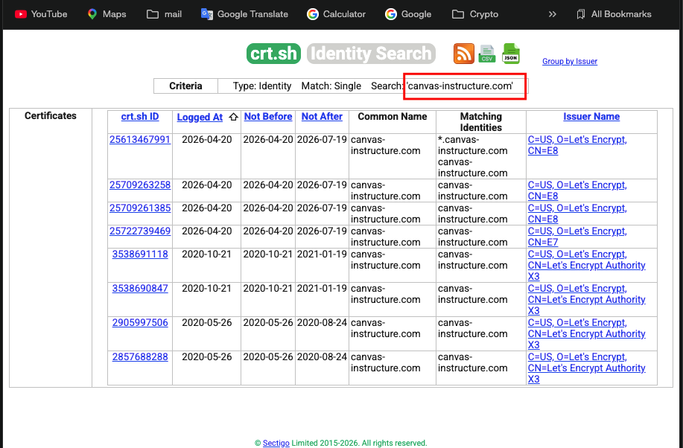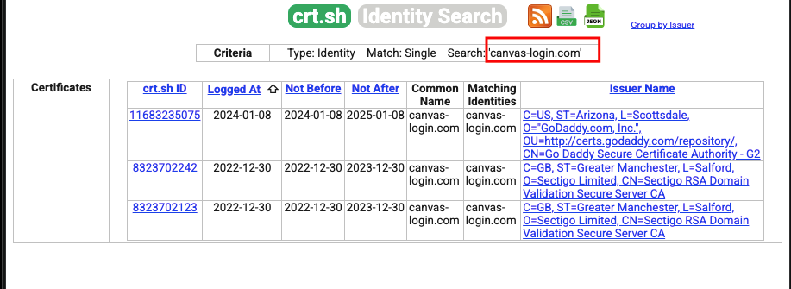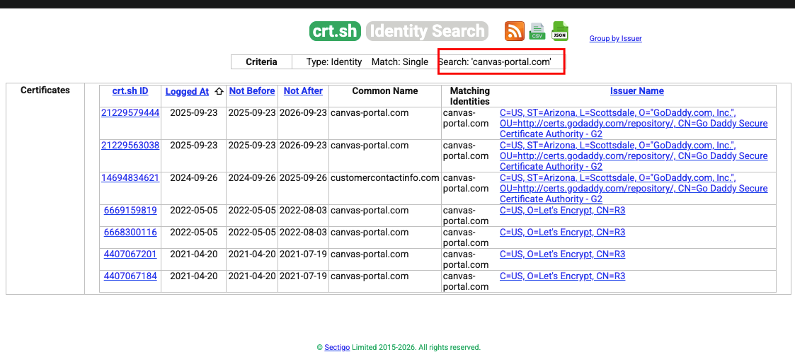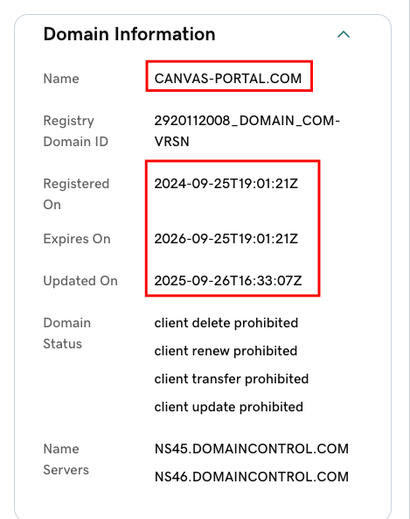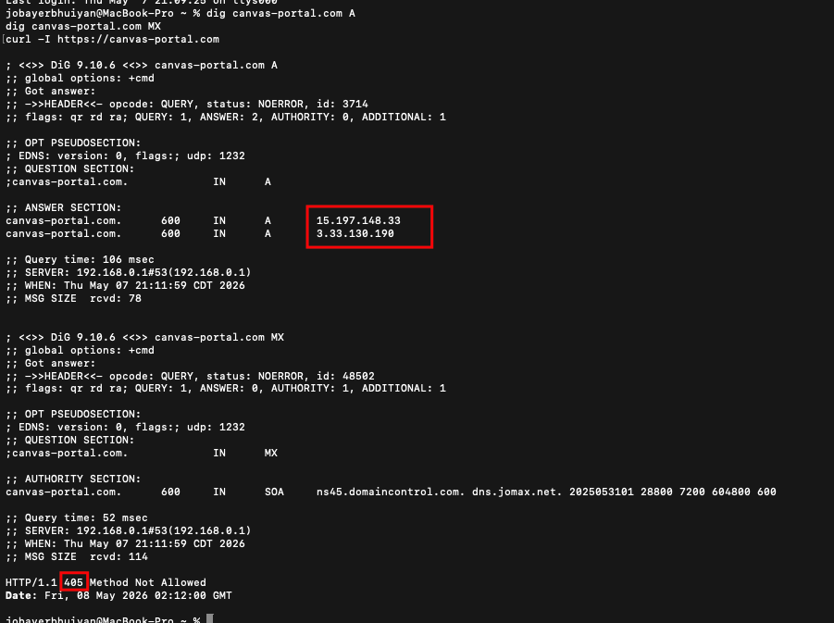

The 405 Method Not Allowed on a HEAD request means the server is actively rejecting non-GET/POST methods. There is a live web application running on this domain right now.
No MX records means it's not set up for sending email, so this is purely web-based phishing infrastructure, likely a credential harvesting portal.
Timeline summary of what you found:
- Sept 25, 2024 — domain registered (one month before C0059 begins)
- Sept 26, 2025 — domain updated/renewed (active maintenance)
- May 7, 2026 — Canvas breach goes public, domain still live on AWS

